RT-241 dt.31-12-2013
Telephone No. 0866 2455614
Fax: 0866 2452102
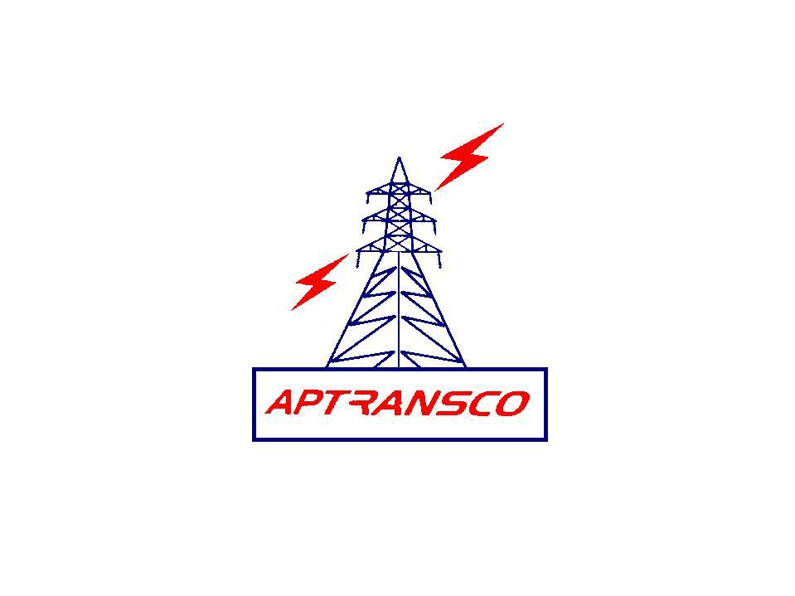

TRANSMISSION CORPORATION OF ANDHRA PRADESH LIMITED

LOCAL PURCHASE ORDER IN DUPLICATE

From To
The Chief Engineer, M/s Shashank Enterprises,
Zone, A.P.TRANSCO D.No.8-5-245,
Gunadala, Lakshmi Nagar,
Vijayawada Karimnagar -505 001
Tele No: 98669 83300

LPO.No.CE/Zone/VJA/Tech/AE-2/LPO.No. 31/13-14/D.No.1362 /13, dt. 30.12.2013

Dear Sir,
Sub:- A.P.TRANSCO- Zone, Vijayawada- Supply of spares for 33KV CGL make SF6 circuit breaker, Type: 30SFGP-25A available at 132KV substation, Chilakaluripeta - Detailed purchase order - Issued - Reg

Ref:- 1. Quotation of ref of M/s.CGL, Secunderabad: YS/SC/RSR/13-14/O/
APTRANSCO/VIJ/054, Dt.21.11.2013
2. Your ref: KS1041CG2013, dt.22.11.2013
3. Lr.No.SE/TL&SS/VJA/O&M/F.2(a)/D.No.2521/2013,dt.17.12.2013.
* * *
I, acting for and on behalf of Transmission Corporation of Andhra Pradesh Limited (herein after called the A.P.TRANSCO) accept offer of M/s. CGL, Secunderabad dt.21.11.2013 cited in the above reference for supply of spares for 33KV CGL make SF6 circuit breaker, Type: 30SFGP-25A available at 132KV substation, Chilakaluripeta of the above cited correspondence and subject to the terms and conditions setout in the order.
- SCOPE OF SUPPLY: This contract relates to the supply of materials as detailed in clause.2 below.
- SCHEDULE OF MATERIAL AND PRICES:
Sl.  No. | Description | Qty | Rate  Rs Ps | Unit | Amount  Rs Ps
 | Spares for 33 KV SF6 Circuit Breaker, Make: CGL Type:30-SFGP-25A
1 | O Ring G-170 | 6 Nos. | 2249.00 | Each | 13494.00
2 | O Ring P-120 | 6 Nos. | 1624.00 | Each | 9744.00
3 | Anabond 681/KE44 (Gas) (100g) | 3 Nos. | 412.00 | Each | 1236.00
4 | Anabond 680 | 3 Nos. | 344.00 | Each | 1032.00
5 | Cloth/ Scrub paper/ Emery pad | 5 Nos. | 31.00 | Each | 155.00
6 | Darina Grease 250 gms | 1 No. | 525.00 | Each | 525.00
7 | Anti-Rusting Spray CRC(1 bottle-ML) | 3 Nos. | 437.00 | Each | 1311.00
8 | O Ring P-7 | 10 Nos. | 250.00 | Each | 2500.00
9 | Molykote A spray/ CRC Spray | 1 No. | 437.00 | Each | 437.00
10 | Absorbent | 2 Kgs | 4809.00 | Kgs | 9618.00
11 | O Ring P-14 | 3 Nos. | 312.00 | Each | 936.00
12 | O Ring P-63 | 3 Nos. | 687.00 | Each | 2061.00
13 | O Ring P-18 | 10 Nos. | 250.00 | Each | 2500.00
 | Sub-Total |  |  |  | 45549.00
 | VAT @5% on Sub-Total |  |  |  | 2277.45
 | P&F @2.5% on Sub-Total |  |  |  | 1138.72
 | F&I @2.5% on Sub-Total |  |  |  | 1138.72
 | TOTAL |  |  |  | 50103.90
Or Say: 50,104/-
(In words rupees Fifty thousand one hundred and four only)

- PRICES: The prices indicated in clause.2 above are firm and for delivery F.O.R TLC stores, Gunadala and are not subject to any variation on any grounds. The prices are inclusive of standard packing and forwarding, freight and transit insurance charges and VAT as mentioned in clause No. (2).

- TRANSIT INSURANCE: The materials shall be duly insured by you. You are responsible for settlement of insurance claims and replacement of lost / damaged / short supplied materials.

- SALES TAX: VAT @ 5% is included in clause 2. The A.P.TRANSCO Tin No. is 28760127045.

- EXCISE DUTY: The prices indicated in clause No.2. above are inclusive of excise duty. Present rate of excise duty 12.36% for relays.
You shall furnish the following certificate with the invoice
‘Certified that the Excise duty claimed in the invoice is adjusted in the personal ledger account maintained by the Central Excise Department on “. You shall also agree that if at any time, any central excise duty reported to have been paid by you, has not been paid or a lesser amount has been paid by you shall refund such amounts irrespective of time. Any benefit due to MODAVT scheme shall be passed on the A.P.TRANSCO

7. DELIVERY:
The proforma invoice shall be submitted with in one week from the date of receipt of this purchase order and the materials described in clause No.2 shall be dispatched within 10 weeks from the date of confirmation of readiness of cheque from the Superintending Engineer/ TL&SS/ Vijayawada.

Any variation up or down in excise duty or sales tax or other statutory levies or new levies introduced by the Government after placing of this purchase order shall be to A.P.TRANSCO’s account.

Provided that in cases where the delivery schedule is not adhered to by you and there are increases in excise duty or sales tax or other statutory levies of new imposts after the agreed delivery dates, you shall bear the impact of these levies and if there is downward variations/revision the A.P.TRANSCO shall be given credit to that extent.

You are also requested to dispatch the materials only on receipt of confirmation of readiness of cheque from the Superintending Engineer/TL&SS/ Vijayawada.

8. PENALTY: In case of delay in delivery of materials, whatever may be the reason, penalty at the rate of ½% per week or part thereof subject to a maximum of 5% of the purchase order value will be levied.

9. TERMS OF PAYMENT:
100% payment will be made against proforma invoice. The proforma invoice in triplicate may be submitted immediately to the Superintending Engineer TL&SS/ Vijayawada on receipt of purchase order. The material may be dispatched after hearing the confirmation of cheque from the Superintending Engineer/ TL&SS/ Vijayawada. Also actual dispatch details may be intimated to the Superintending Engineer/ TL&SS/ Vijayawada.

10. DESPATCH INSTRUCTIONS: The materials as per clause No. (2) shall be consigned to the Asst. Executive Engineer/Gunadala stores/Vijayawada and dispatched by Road to the consignee freight prepaid as indicated in clause No.(3).

All original documents shall be sent to the Superintending Engineer/ TL&SS/ Vijayawada for arranging payment. Copies of invoices shall be marked to the Superintending Engineer/ TLC/ Vijayawada.

A Photostat copy of the L.R shall be sent one each to the Superintending Engineer/ TL&SS/ Vijayawada, and the Executive Engineer/ TLC/ Vijayawada immediately after dispatched through any reputed transporting contractors.

11. PACKING: All the materials shall be securely packed in such a manner as to withstand rough handling during transport up to site. All the above materials shall be adequately protected before dispatch to prevent damage, corrosion and entrance of foreign matter.

12. LOSS OR DAMAGE: External damages or shortages that are prima facia, the result of rough handling in transit or due to defective packing will be intimated to you within a fortnight of receipt of the materials. Internal defects / damages or shortages of any internal parts which can not ordinarily be detected on a superficial visual examination though due to bad handling in transit or defective packing or other reasons would be intimated within two months from the date of receipt of materials. In either case, the defective or damaged materials shall be replaced and shortages made good by you, free of cost to the A.P.TRANSCO.

13. CORRESPONDENCE:
  - Your acknowledgement of receipt of this order and all correspondence of general or technical nature shall be addressed to this office.

  - All correspondence regarding dispatch, payments etc., shall be addressed to Superintending Engineer/ TL&SS/Vijayawada with copies marked to this office.

14. JURISDICTION: All and any disputes or differences arising out of or touching this orders shall be decided by courts or tribunals situated in Vijayawada. No suit or other legal proceedings shall be instituted elsewhere.

15. ACKNOWLEDGEMENT: Please acknowledge the receipt of this order with your confirmation of its acceptance. The additional copy enclosed may please be returned with your signature in token of your acceptance.

Yours faithfully

CHIEF ENGINEER
APTRANSCO
VIJAYAWADA ZONE

We accept the terms and conditions of this order.

SIGNATURE OF THE SUPPLIER

Copy communicated to the Chief Engineer/ Transmission/ Vidyut Soudha/ Hyderabad

Copy to: -
The Superintending Engineer/TL&SS/ Vijayawada
The Superintending Engineer/ TLC/ Vijayawada
The Divisional Engineer /TL&SS/ Guntur
The Executive Engineer/TLC / Vijayawada

The Asst Divisional Engineer/O&M., O/o the Chief Engineer/ Zone/ Vijayawada

